 | Aigles  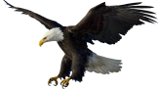 | Tigres  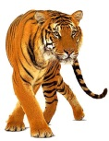 | Requins  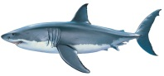 | Serpents  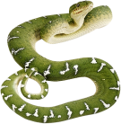 | Vélociraptors  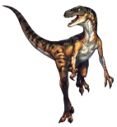 | Loups  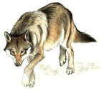
Aigles

Tigres
Requins

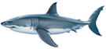
Serpents
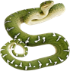
Vélociraptors
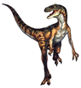
Loups
